

NAME: BISMA FATIMA
CLASS: CS A
ROLL NO: F24605036
COURSE: OBJECT ORIENTED PROGRAMMING
COURSE CODE: CS-123
LECTURER: MISS TAYYABA KALSOOM

INLAB 04 [WEEK 04]

TASK 01
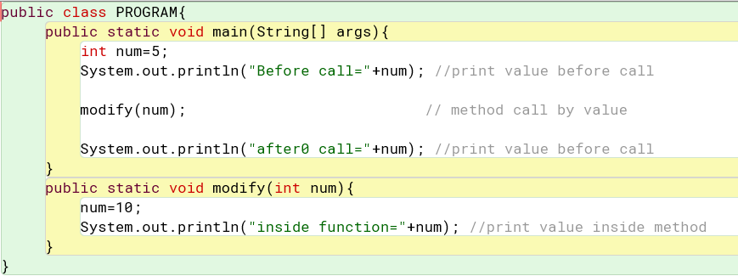
OUTPUT
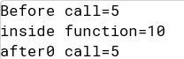

TASK 02
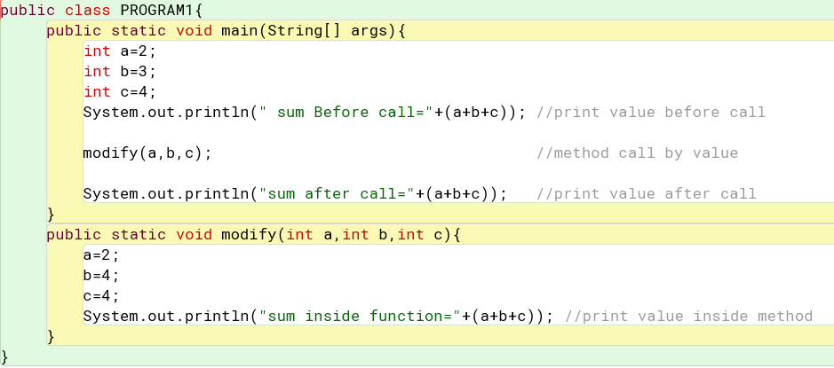
OUTPUT
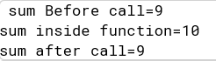

TASK 03
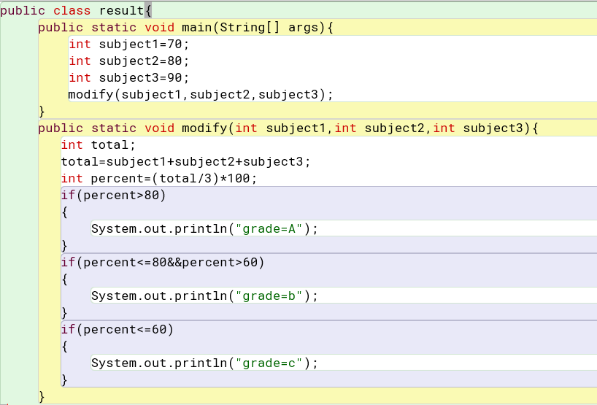
OUTPUT
TASK 04
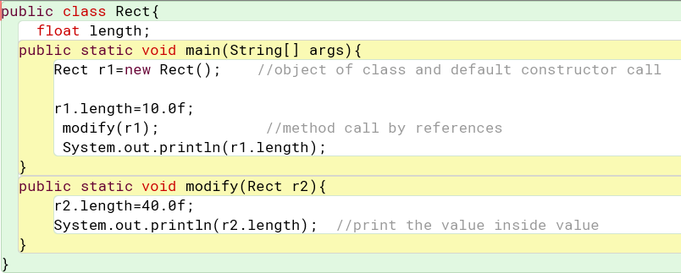
OUTPUT
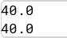

TASK 05
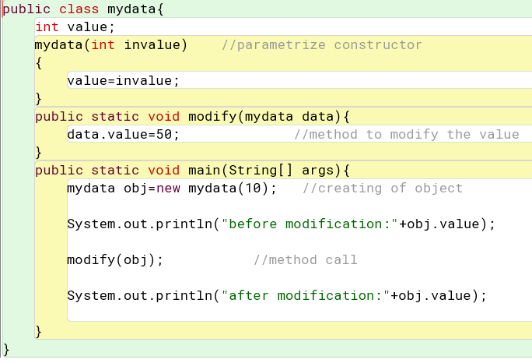
OUTPUT
